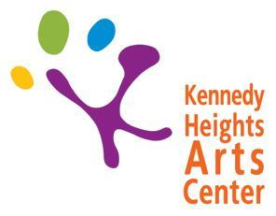

6546 Montgomery Road
Cincinnati, OH 45213
Phone: 513.631.4278

Summer Camp 2020 Proposal Form
Please return this form to Brittany Vernon, Director of Arts Engagement and Learning by
January 31st, 2020

Week-long camps will be held between the week of June 1st and the week of August 3rd (ending August 7th). Camp is 5 days: Monday-Friday from 9:30am-2:30pm. (Exception is a 4-day week for July 4th holiday week). Instructors are expected to be at KHAC from 9am-3pm daily.
Compensation is $150/day x 5 days = $750 total
*Themes are highly encouraged

Instructor Name: _____________________________________________________________

Phone Number: ________________________________ Email: _________________________________

Camp Title (tentative): ___________________________________________________

Age Group (preferred, not guaranteed): _______________________________________

All Weeks Available: _________________________________________________________

Short Description of your camp (will be edited, used for marketing):

Project Plan By Day – Please describe the projects/activities for each day and needed materials.

Day 1:

Materials Needed:

Day 2:

Materials Needed:

Day 3:

Materials Needed:

Day 4:

Materials Needed:

Day 5:

Materials Needed:

Preferred Space to hold camp (circle one): Basement Art Studio Annex Event Space Digital Media Lab
*Please note that no painting or hanging of items on the walls is allowed inside or outside of the Annex

Additional needs for the camp:

Please submit this form for EACH camp you are proposing. Instructors may propose up to 5 camp ideas.

If you have any questions or need any additional information, please contact me via email at
brittany@kennedyarts.org or call me at 513-631-4278. Thank you!

